Java 8

News:

Lambda expressions

Functional Interfaces

Default methods in interfaces

Static method in interfaces

Predicate, Function, Consumer (predefined functional interfaces)

:: double colon operator (method reference & constructor reference)

Stream Api

Date and Time Api

Enable functional programming with lambdas

Parallel programming with parallel streams

Lambda expression

Enable functional programming

More readable maintainable concise code

Use apis easily

Enable parallel processing

Lambda expression is an anonymous function (not name, modifiers or return type)

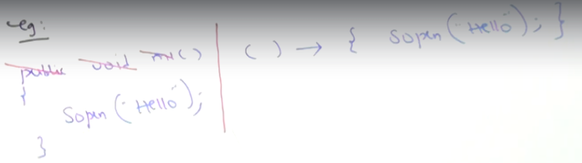

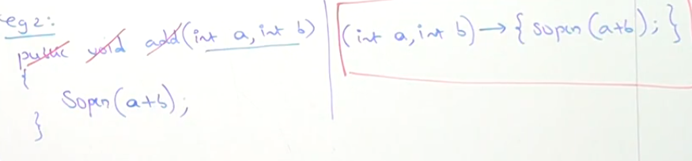

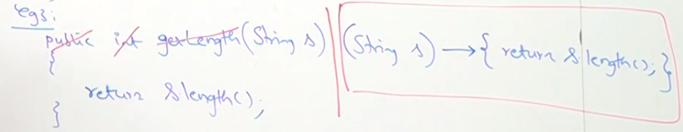

If only one statement in the body of the lambda, then curly braces can be removed

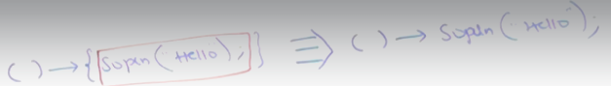

Type inference, compiler is able to guess the type of the params

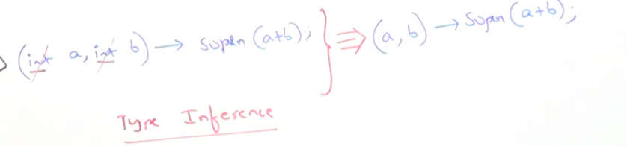

Compiler based on context can identify if a value will be returned, so the return keyword is not required.

Also if there is only one parameter, the parenthesis are optional

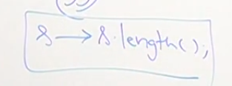

Functional Interface

If the interface contains only one abstract method. Can be used to call lambda expressions.

It can has any number of default or static methods

Ex: Runnable, Callable, Comparable

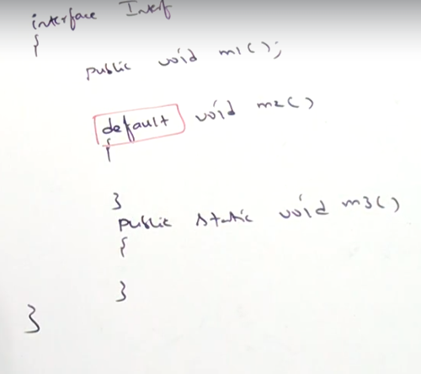

@FunctionalInterface

Mark an interface as functional interface, if it doesn’t comply with one abstract method only, it will give a compiler error. Its not required to use lambdas though

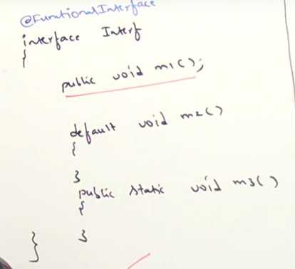

Functional interfaces on inheritance

The interface should have only one abstract method, on itself or on a parent to be functional.

If the child interface overrides the same abstract method of the parent and that is the only abstract method in both, then both are functional interfaces

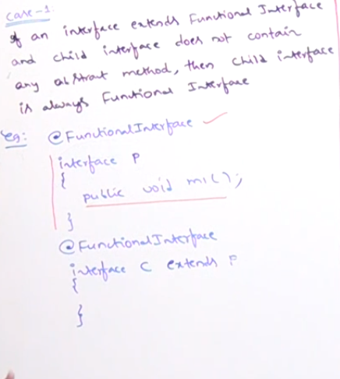

Call lambda method

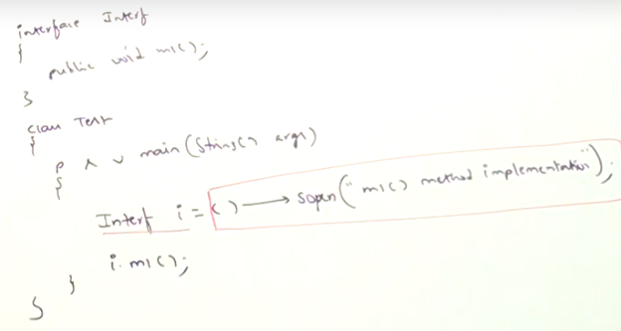

i.mi() abstract method from interface will call the lambda defined.

There is not need to implement interface, with functional interface we can assign directly the lambda (implementation) at initialization.

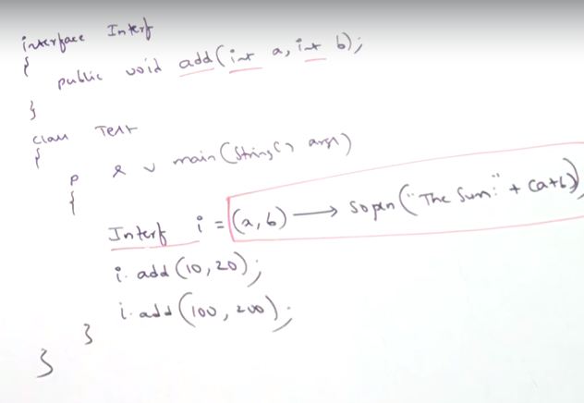

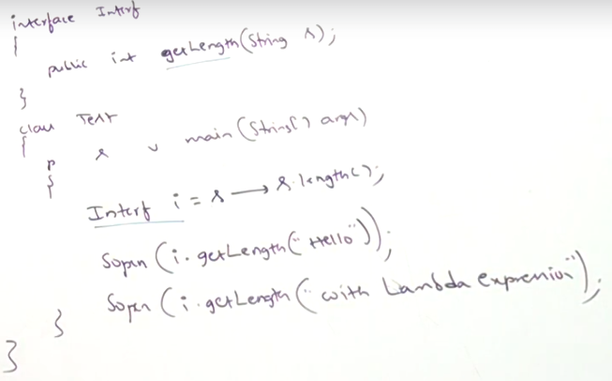

Lambda with Runnable

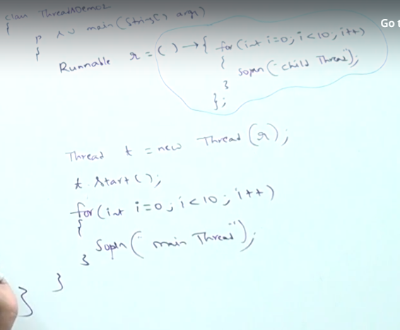

Ternary operator

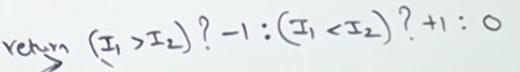

List sort with lambdas

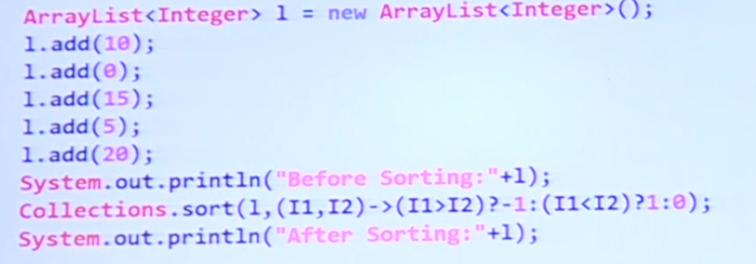

Collections.sort is expecting the list and the comparator (functional interface) lambda will be the corresponding to the compare method of the comparator

TreeSet descending order example, Treeset constructor accepts a Comparator object which will determine how to order the values

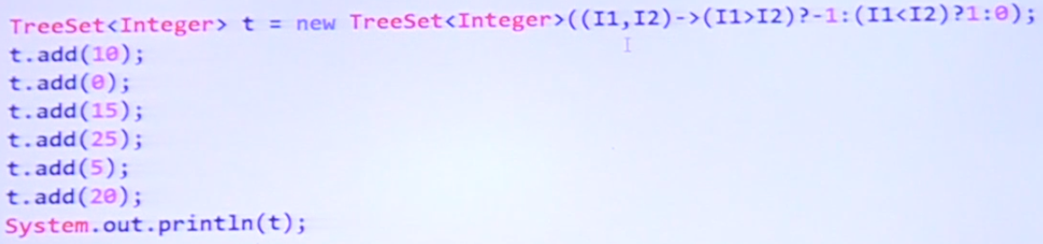

TreeMap descending order example (will order based on the key), same lambda no need to specify

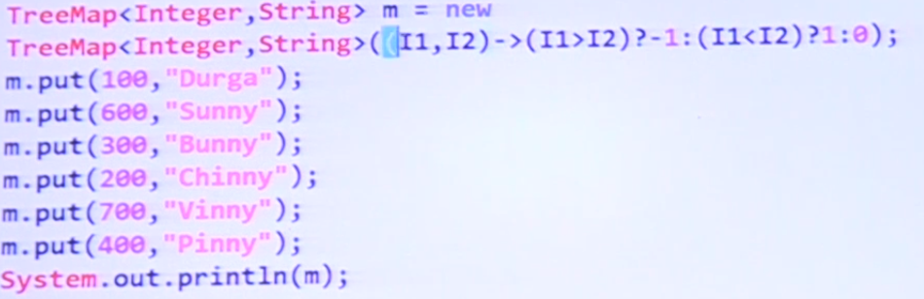

Customize object soring with lambda

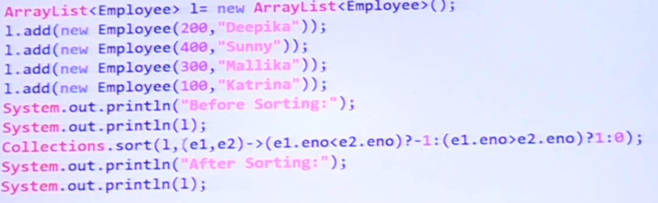

Anonymous inner classes (nameless inner class) vs lambda (there might be a possibility to exchange for a lambda but not always

Anonymous inner class, its implementing the runnable interface but not giving any name

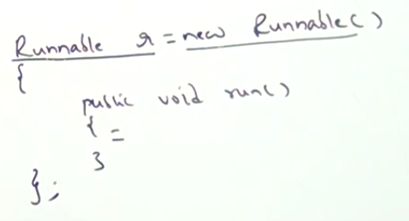

Anonymous inner class implemented with lambda:

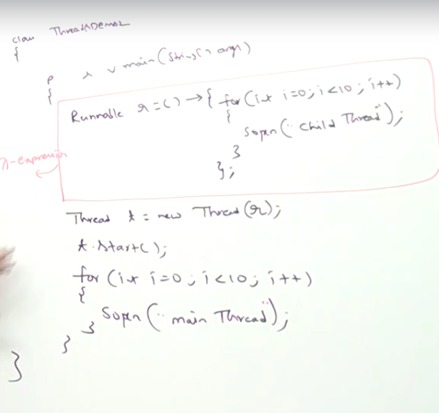

It is possible to include the lambda direct without creating the object

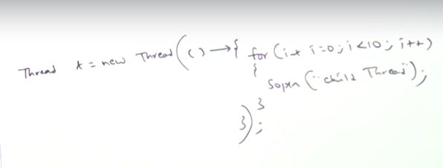

Lambdas can’t extend concrete class or abstract class

Inside lambda expression it is not possible to declare instance variable, they are local variable.

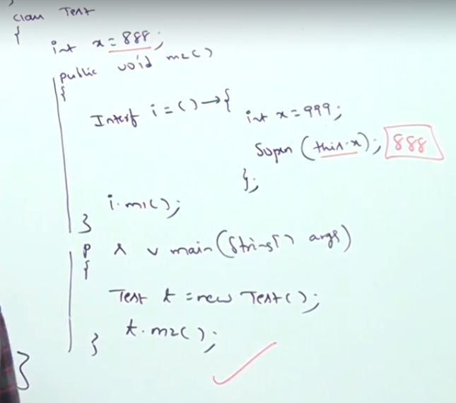

This.x will print 888 since the this Is referring to the outer actual class which is Test, the lambda is not an instance, they only have local vars

Use this inside lambda to access outer class instance vars

We can access outer instance variables and local method variables from the lambda:

Local variables from the lambda are final cannot change, you can change outer instance vars inside the lambda correctly

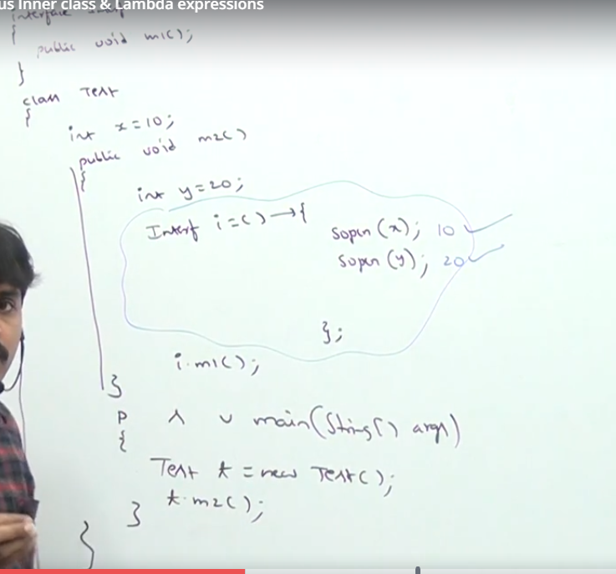

Default methods inside interface. 1.8 java

Before java 1.8 all methods inside interface were public abstract whether you say It or not.

All vars are public static final in the interface whether you declare it or not.

From 1.8 we can declare concrete methods (default methods)

Default method can be override by its implementing class (no need to add the default keyword on the method signature)

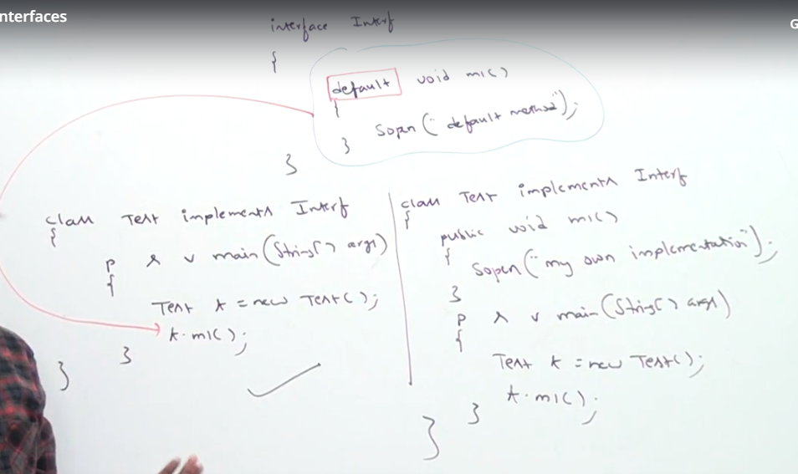

Default method with multiple implementations

If two interfaces share the same method there will be ambiguity, to solve it we need to override the method in the implementing class.

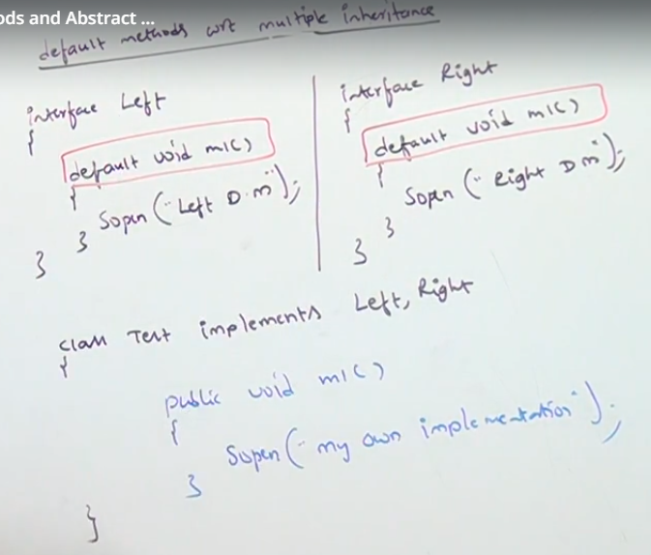

Also you can choose one of the methods on the implementation:

Left.super.mi() will use Left interface method on the implementation

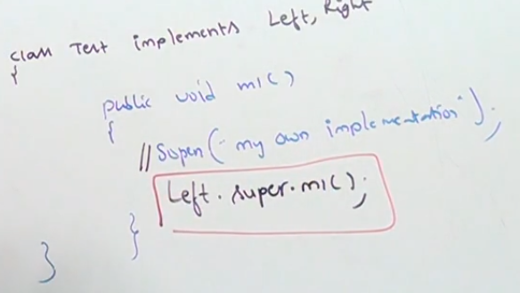

Difference interfaces with concrete default methods vs abstract classes:

You can decide if ignore the default method on the interface, on the abstract class you need to implement the method.

Interface cannot have constructor, abstract class does

Inside interface every var is always public static final, abstract classes can have instance variables

Inside interface no static block, inside abstract it is possible

Interface cant override object class methods like toString()

Static methods inside interface

Any class even ifs not an implementing class can call that method.

Use for general utility methods

Implementing classes can only call those methods calling in a static way InterfaceName.staticmethod()

Interface static methods overriding

Overriding is not applicable for static methods

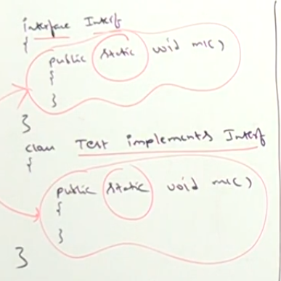

It is not overriding, each class will have its own static method

1.8 upwards can have main method since static methods are available

Predefined functional interfaces

Predicate, Function, Consumer, Supplier

Predicate

Boolean conditional checks

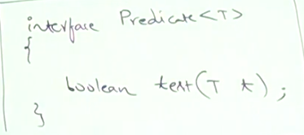

Predicate example, given number greater than 10 or not

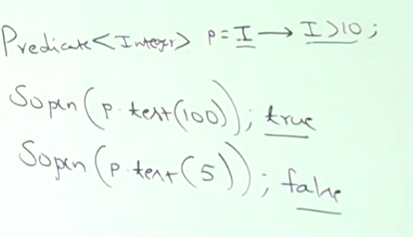

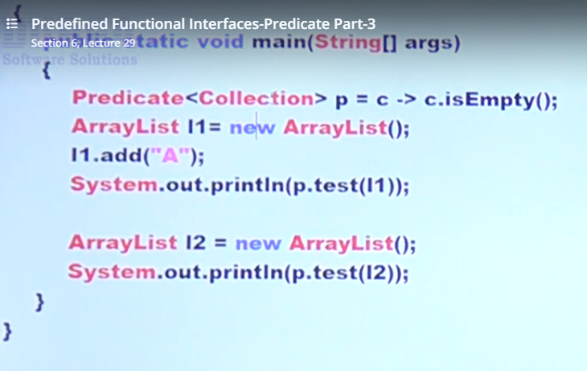

Predicate joining (you can join multiple predicates in a single predicate)

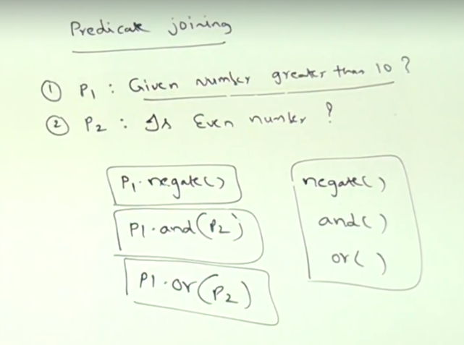

Negate(), and(), or() default methods from predicate

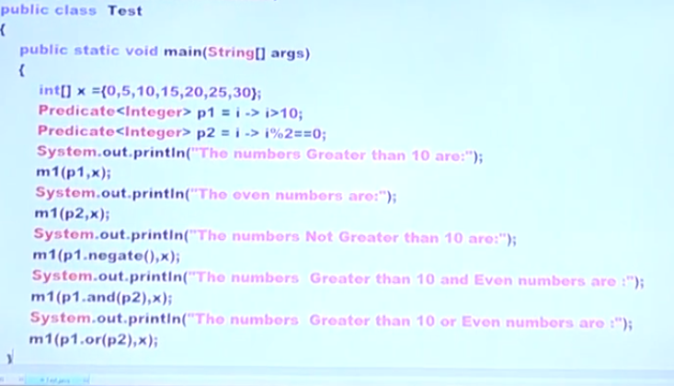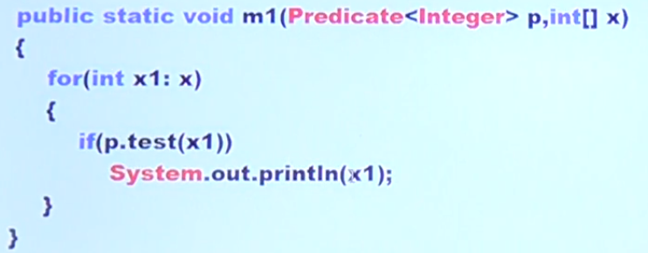

Ex 2 print if starts with k

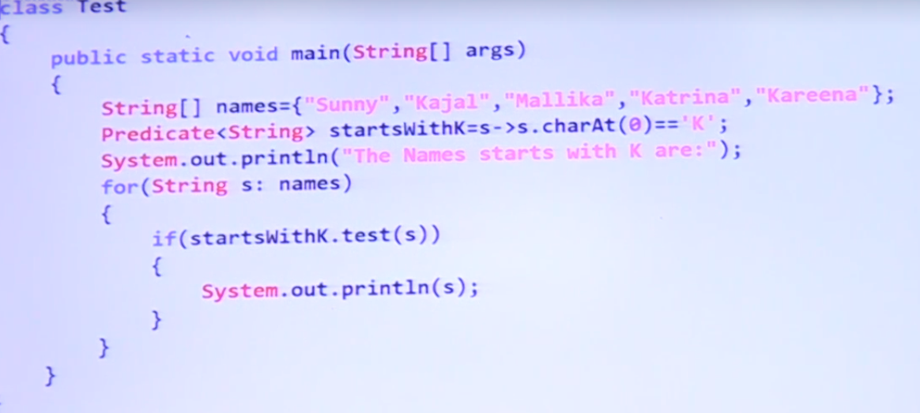

Ex3: remove null and empty string from array

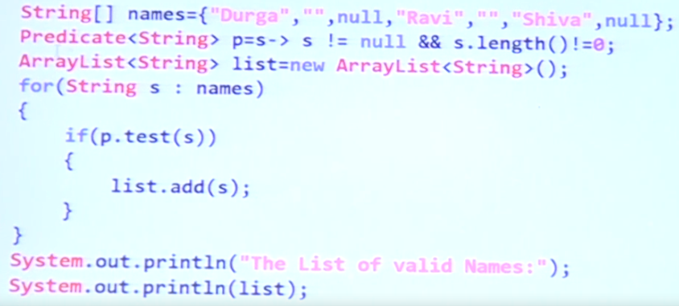

Ex4. Authentication example

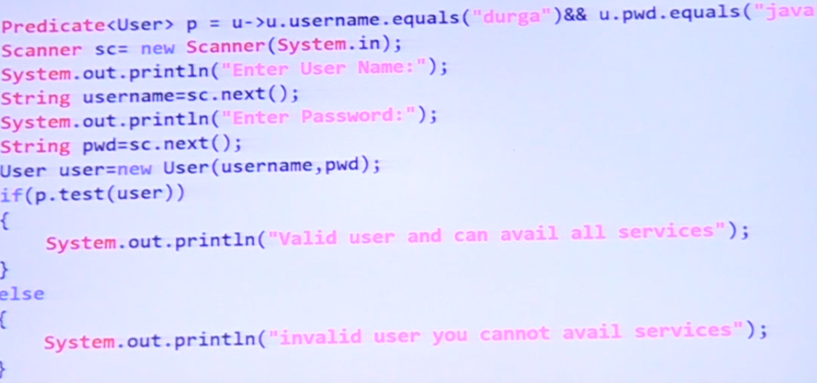

Ex5. Software engineer allowed into pub

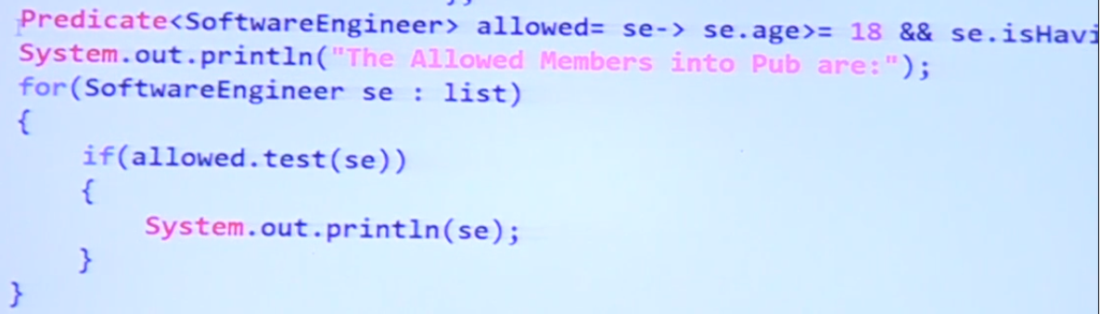

Predicate static method isEqual()

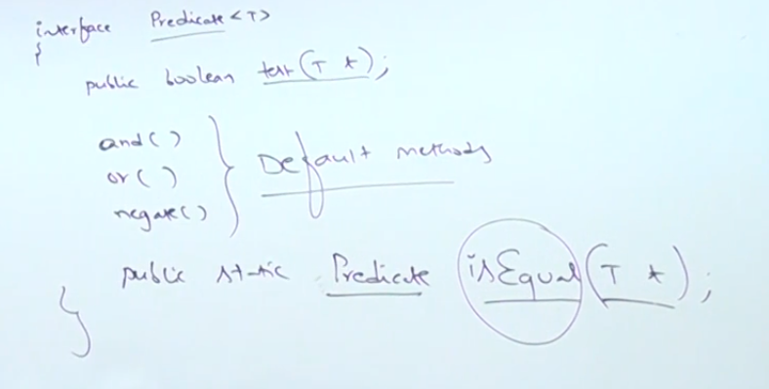

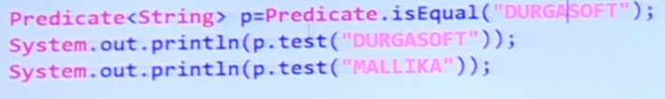

Predefined Functional Interfaces Function

Receives one input and Can return any value

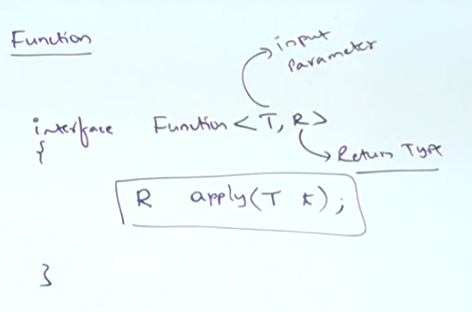

Get length of a string example

Function<String, Integer> f = s -> s.length();

f.apply(“Fernando”)

Return square of number

Function<Integer, Integer> f = I -> i\*i

f.apply(10);

Program to remove spaces with function

Function <String, String> f = s -> s.replaceAll(“ “,””);

f.apply(“Jose Fernando Arellano”);

ex. number of spaces inside string

String s = “Uno dos tres cuatro”;

Function<String, Integer> f = s-> s.length – s.replaceAll(“ “,””).length();

f.apply(s);

ex. Get total to pay from all employees

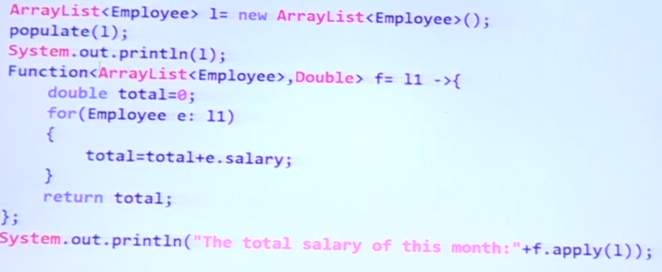

Ex. Increment salary for employees with salary less than 3500 + 477

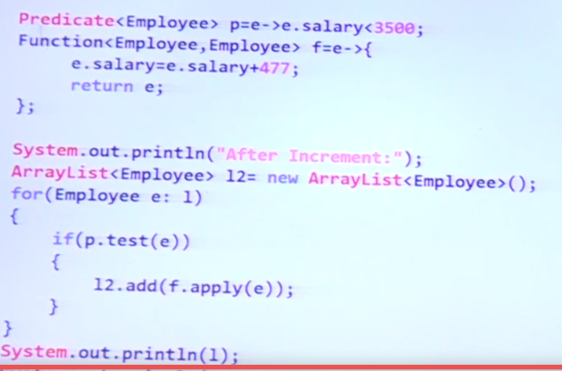

Function chaining (default method andThen, compose)

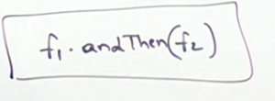 f1 will be applied followed by f2

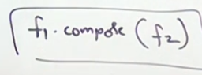 f2 will be applied followed by f2

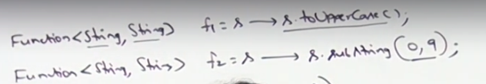

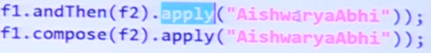

Ex. Difference between compose and andThen

Identity() static method on Function interface

Return a Function with same type, what you provide on the input you get

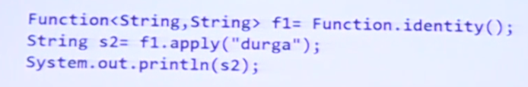 //s2 prints durga

Consumer Functional Interface

Doesn’t return something, just perform an operation.

Receive one type parameter

Abstract accept()

Consumer<String> c = s-> sout(s);

c.accept(“hello”);

ex. Print information about movie

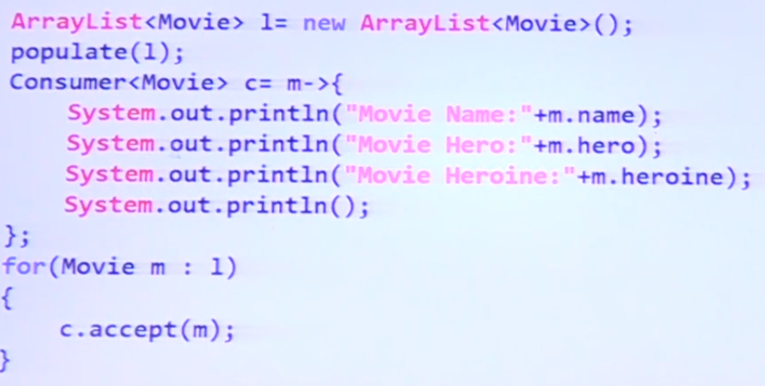

Ex. Display student information only marks > 60

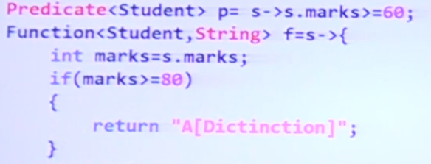

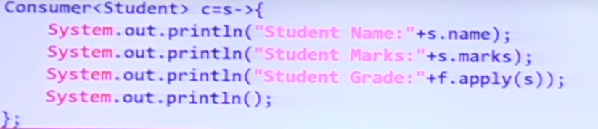

Consumer chaining

AndThen() default method

C1.andThen(c2).andThen(c3).accept(m);

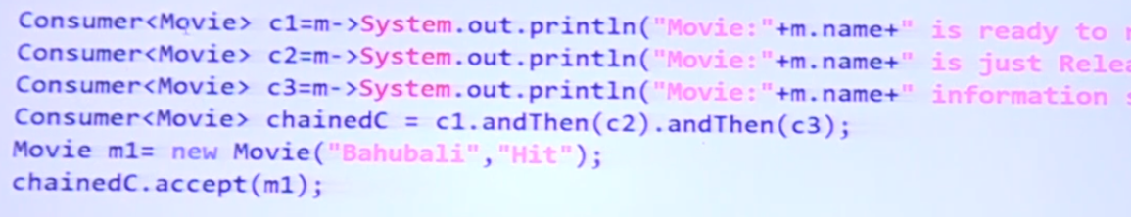

Supplier Functional Interface

No input is provided

Retrieve object from any type

Abstract get();

Supplier<Date> s = () -> new Date();

s.get();

ex. Generate random name with supplier

Supplier<String> s = () -> {

String [] sa = {“Fer”, “Ady”, “mom”, “Dad”, “Pau”};

Int x = (int) Math.random() \* 4 //random generates from 0<= x <1

Return sa[x]; }

s.get();

Random r = new Random();

return r.nextInt((max - min) + 1) + min;

min and max inclusive

ex. Return otp of 6 digits between 0-9

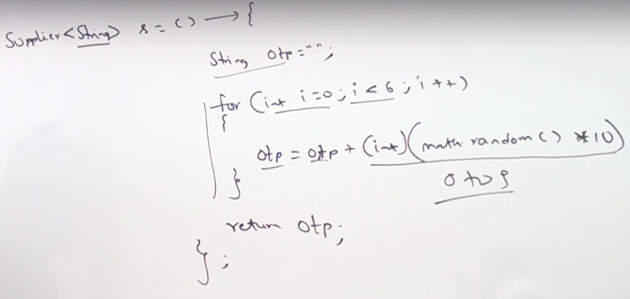

Ex. Get password with letters and special character in odd position and digits from 0-9 on even position 8 character total

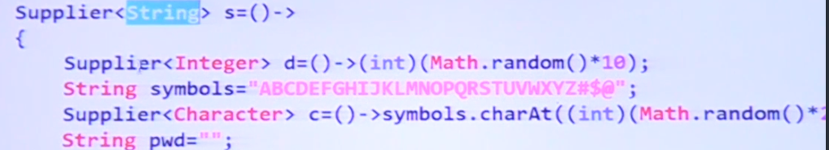

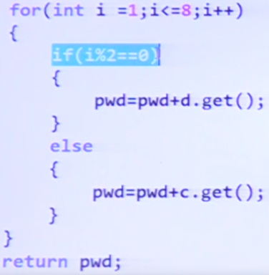

BiPredicate

Can accept 2 input values

Return Boolean

BiFunction

Can accept 2 input values

Return any object

BiConsumer

Can accept 2 input values

Doesn’t return anything

BiPredicate

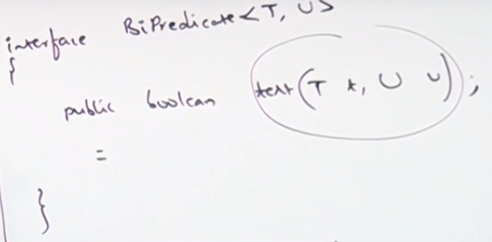

BiPredicate<Integer, Integer> bp = (I,k) -> (i+k)%2==0;

Bp.test(10,10); //true

Default methods and(), or(), negate() are also available

BiFunction

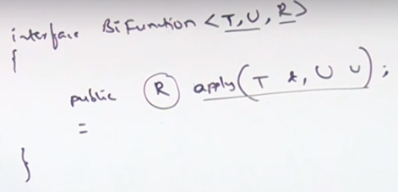

Bifunction<Integer,Integer, Integer> f = (I,j)-> i\*j;

f.apply(10,200);

ex. Create student object with Bifunction

ex. Input employee, timesheet return salary

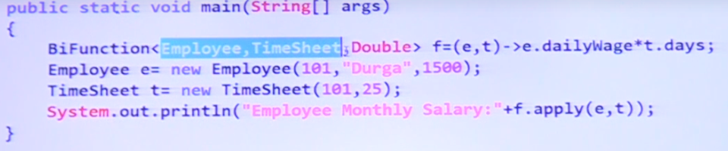

BiConsumer

Biconsumer<String, String> c = (a,b)-> sout(a+b);

c.accept(“hola”, “ fer”);

ex increment salary for employee

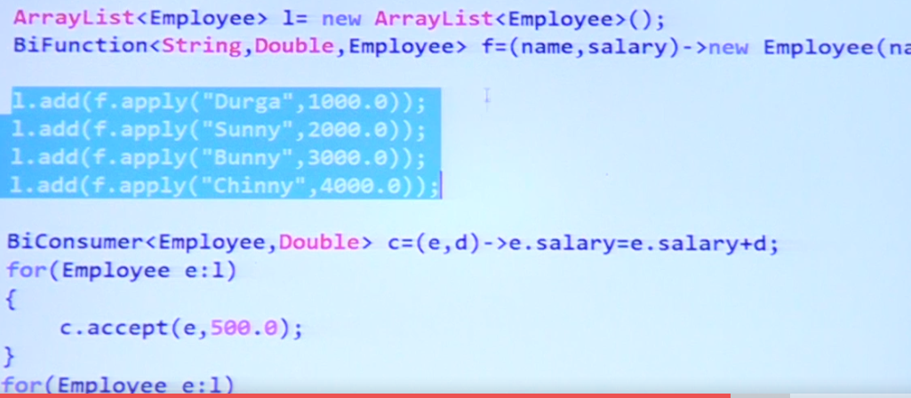

Primitive Type Functional Interfaces for performance with primitive types

Autoboxing, automatic conversion from primitive to wrapper object

Integer I = 10;

AutoUnboxing, automatic conversion from wrapper object to primitive

Integer I = new Integer(10);

Int x = I;

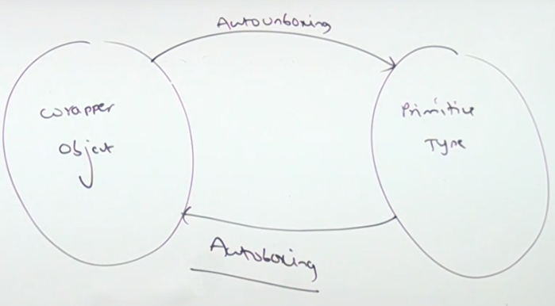

Generics-Type Parameter

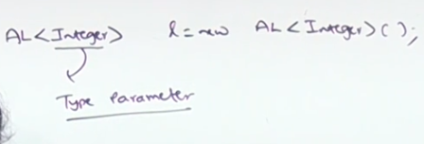

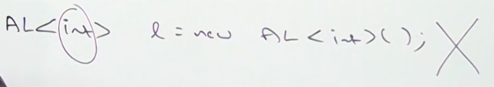

Use Predicate<Integer> for primitives is not efficient, it needs to be autobox and autounbox

IntPredicate

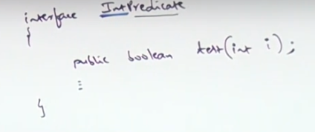

Int [] x = {5,10,15,20}

IntPredicate p = I -> i%2==0;

For(int x1 : x){

If(p.test(x1)){

Sout(x1)}}

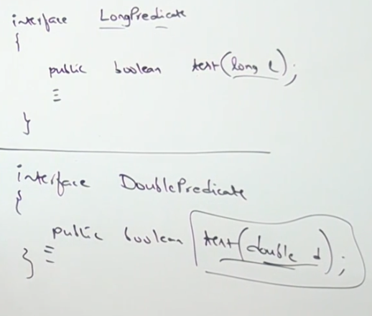

IntFunction<R>

IntFunction<Integer> f = i-> i\*I;

f.apply(10);

ToIntFunction<T>

Can receive any type but the return type will be int

ToIntFunction<String> f = s -> s.length();

f.applyAsInt(“Fernando”);

Interface IntToDoubleFunction

Primitive version to receive and return

IntToDoubleFunction f = i-> Math.sqrt(i);

f.applyAsDouble(2);

Primitive Functions

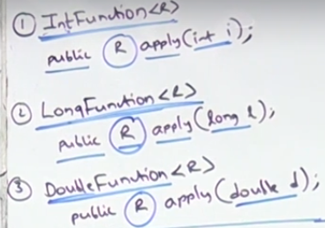

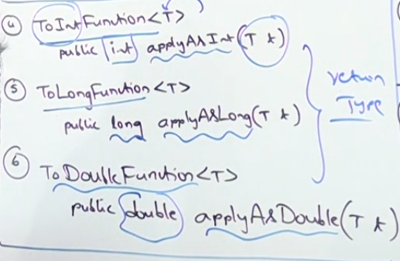

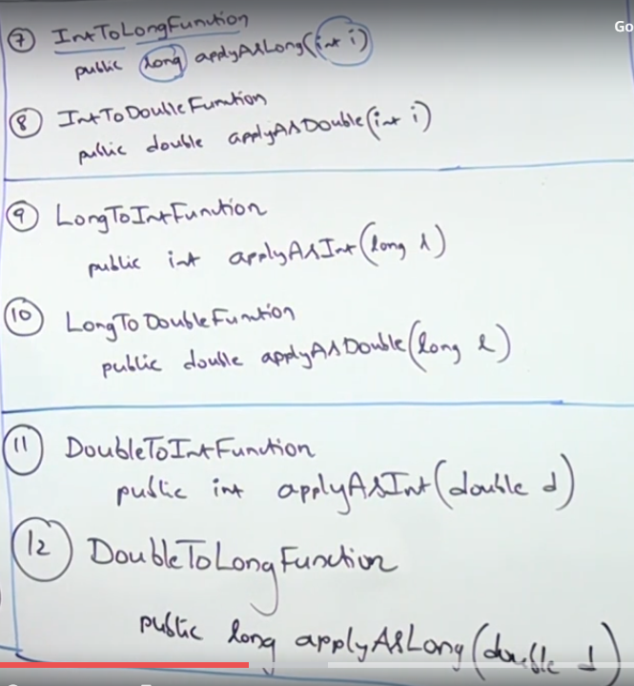

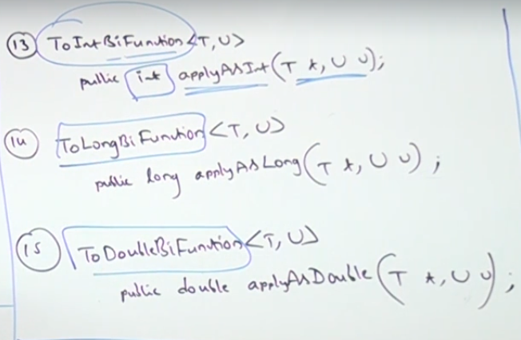

Primitive Consumer version

IntConsumer

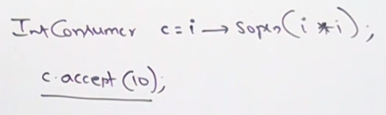

LongConsumer

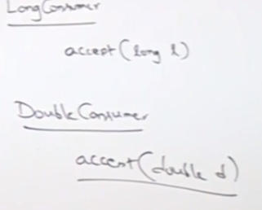

ObjIntConsumer<T>

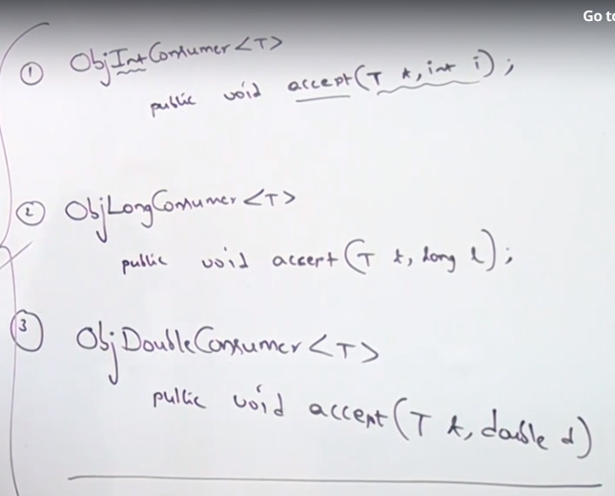

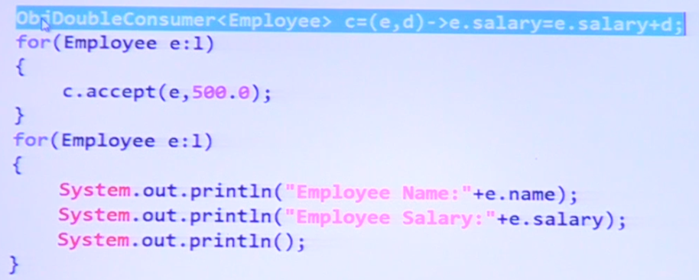

Primitive version Supplier interface

IntSupplier s = ()->(int)Math.random()\*10;

s.getAsInt();

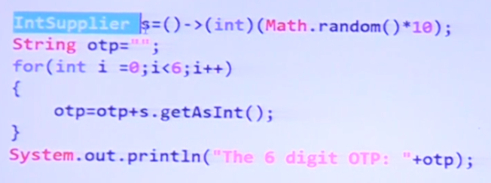

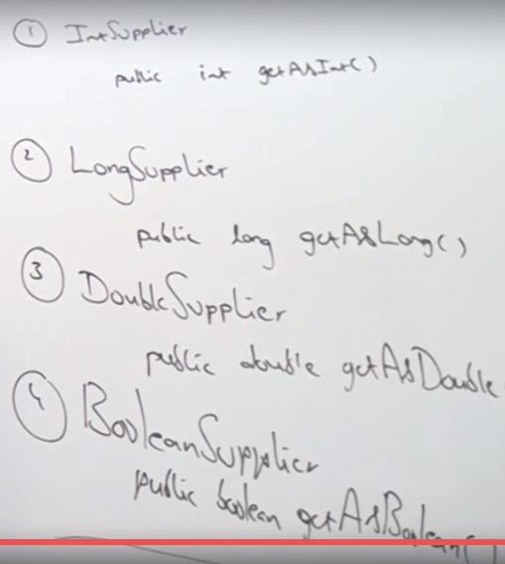

UnaryOperator<T>

If input and return type are equal

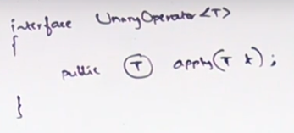

Unary<Integer> u = i-> i\*I; //input and return type are same type

U.apply(10);

Input and Return type is primitive then primitive version Unary

IntUnaryOperator, DoubleUnaryOperator, LongUnaryOperator

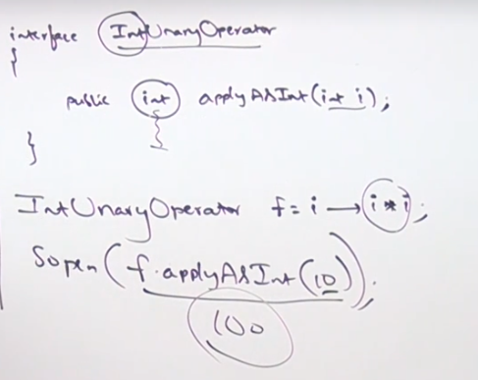

Binary operator

Two inputs and return type are same type

BinaryOperator<String> o = (s1,s2)-> s1+s2;

o.apply(“Fer”, “Hola”);

Binary Operator primitives

IntBinaryOperator f = (i1,i2)-> i1+i2;

f.applyAsInt(10,20);

Method Reference and constructor reference by Double Colon operator

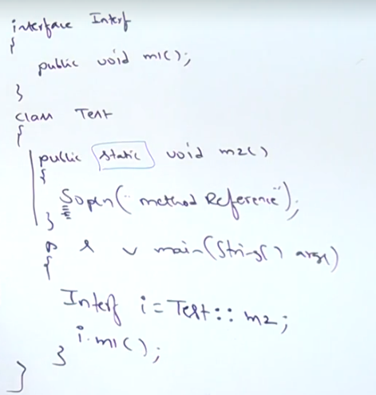

Method reference, instead of give implementation to the functional interface m1 method, it refers to the static method m2, so when i.mi() is call it will refer to the m2 method and will execute this code.

Works for code reusability.

Needs to have same arguments (in this case m1 has no arguments as m2. (static doesn’t affect)

Instead of giving new functionality with lambda, we reuse some existing code

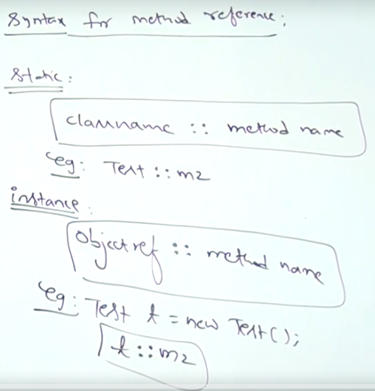

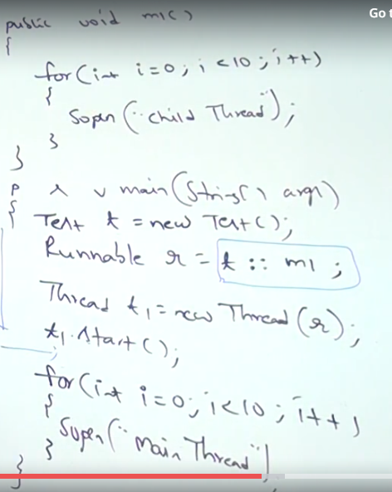

Constructor reference

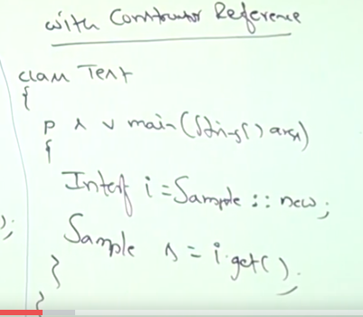

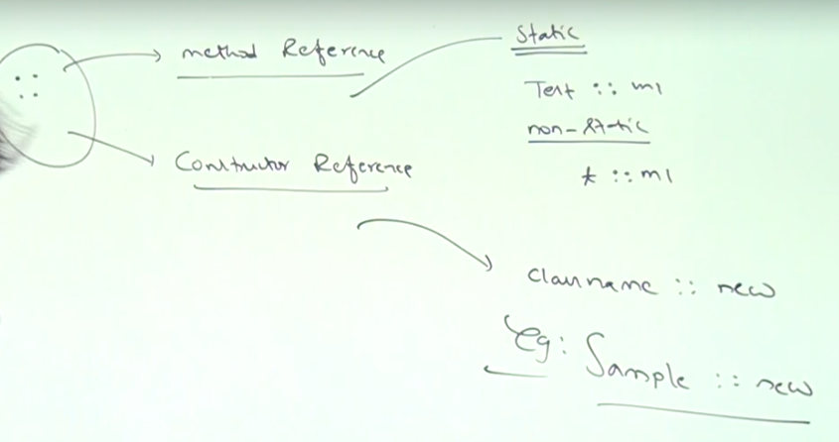

Streams

To perform operations on collections

Collection is a group of objects treat as a single entity.

Streams to process objects from the collection

Filter()

Allows to filter objects from the collection based on a boolean condition

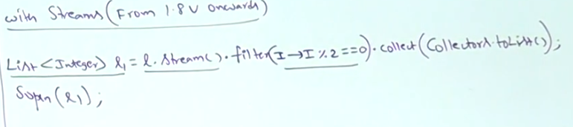

Map()

For every object on the list perform an operation.

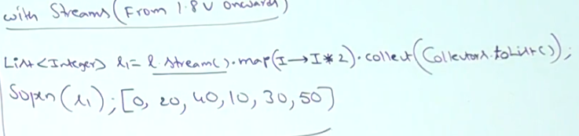

Collect(gets the result list after the stream operations).

Stream s = c.stream(); //any collection

Difference between filter() and map()

Filter for some which fulfill the boolean condition, map for all elements

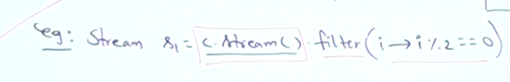

Map() if we want to create a new object

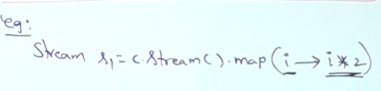

Process Streams (after configuring with filter() or map())

Processing by collect()

Collect, collects elements from the stream and add them to the specified collection.

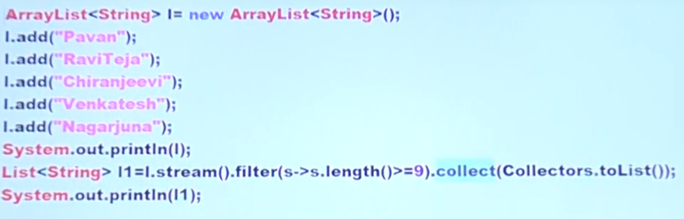



Processing by count()

Return the number of elements present in the stream

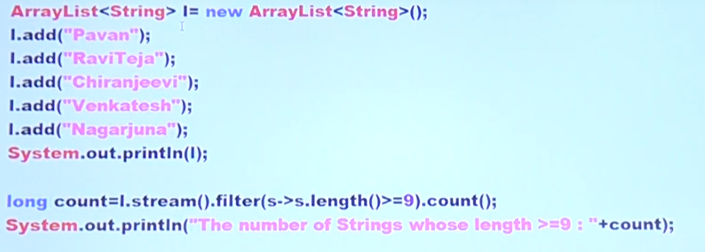

Sorted()

We can sort elements on the stream based on default natural sortin order or based on our own customized sorting order.

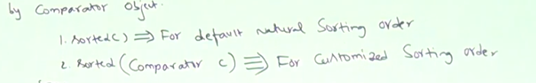

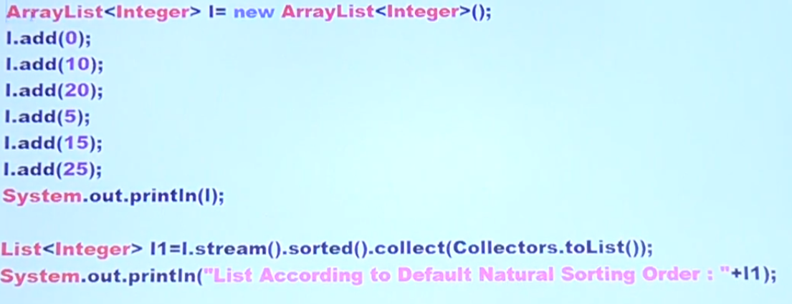





Min(), max()

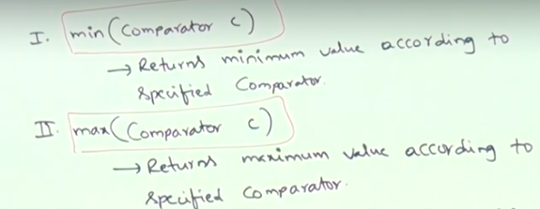

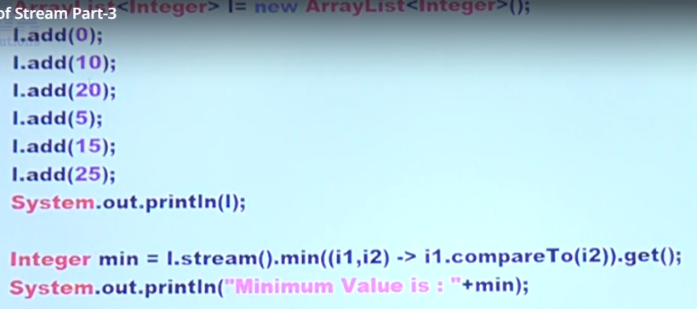

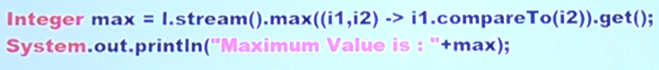

forEach()

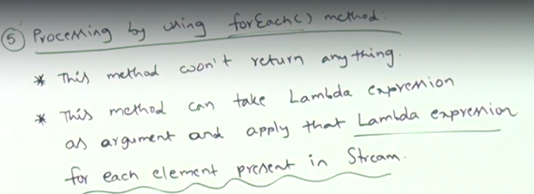

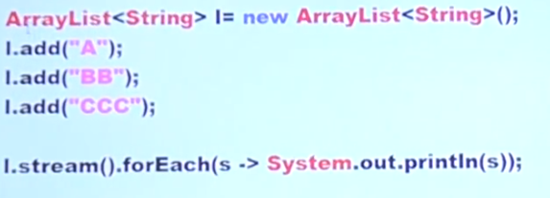

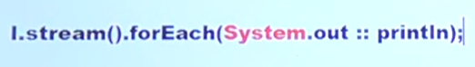

toArray()

elements present on the stream, to copy into specified to array

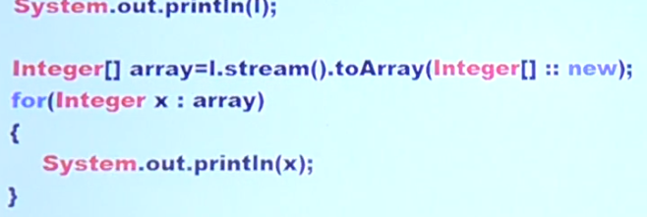

Stream.of()

Stream also apply for group of values and arrays not only streams

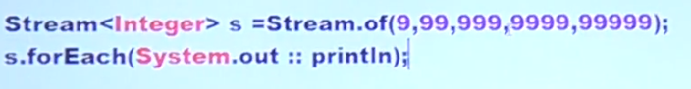

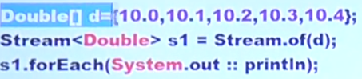

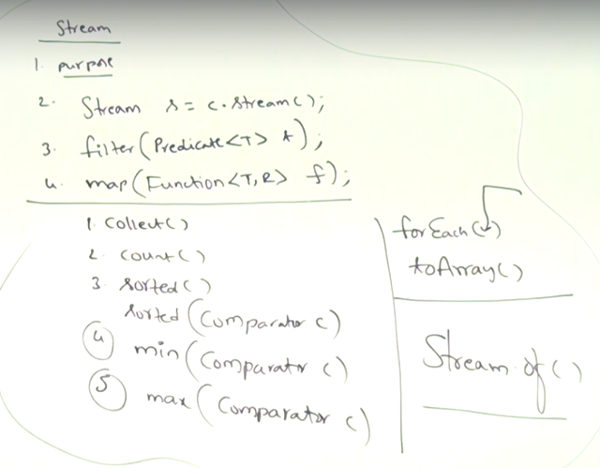

Streams

a stream can be consumed only once. It cannot be reused. If the same stream is used more than once, an error of the form java.lang.IllegalStateException: stream has already been operated upon or closed is raised

Streams terminal operations

Java-8 Stream terminal operations produces a non-stream, result such as primitive value, a collection or no value at all. Terminal operations are typically preceded by intermediate operations which return another Stream which allows operations to be connected in a form of a query.

toArray() collect() count() reduce() forEach() forEachOrdered() min() max() anyMatch() allMatch()

noneMatch() findAny() findFirst()

Streams intermediate operations

Java 8 Stream intermediate operations return another Stream which allows you to call multiple operations in a form of a query. Stream intermediate operations do not get executed until a terminal operation is invoked. All Intermediate operations are lazy, so they’re not executed until a result of a processing is actually needed. Traversal of the Stream does not begin until the terminal operation of the pipeline is executed.

filter() map() flatMap() distinct() sorted() peek() limit() skip()

Date and Time Api(Joda Time Api)

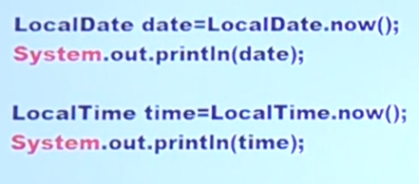

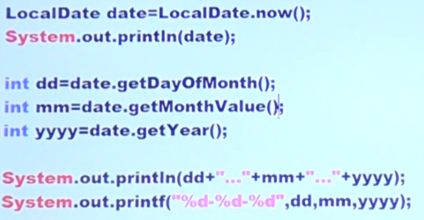

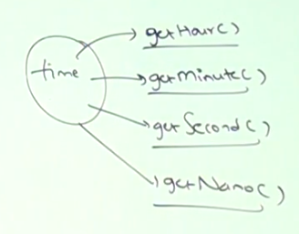

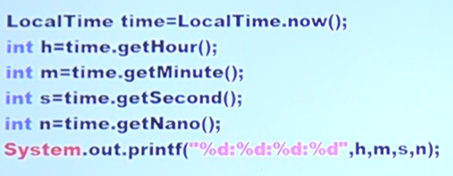

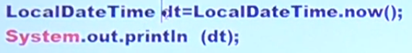

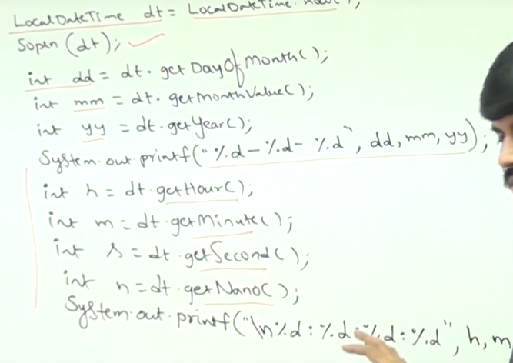

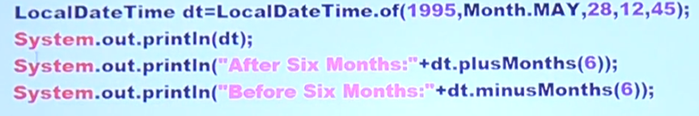

Period

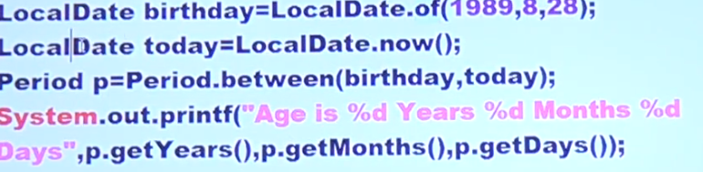

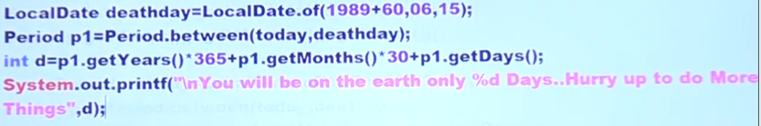

Year

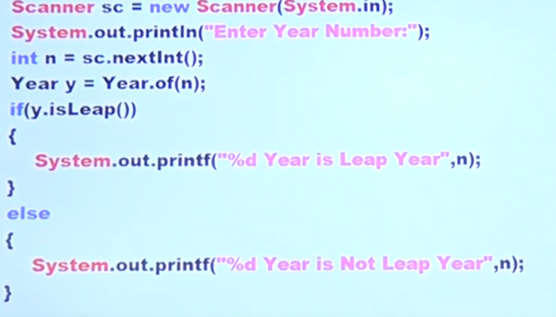

ZoneId

